GIT – Version Control system

Git –version , to check version of GIT

Git config –global –edit

Git config –global user.name “your name”

Git config –global user.email “your email”

` - to config your names

Git init – to make local folder as repository

Git status – to check status of repository

Git add -- to move to staging area

Git commit –m “your messgae” , - to commit the changes

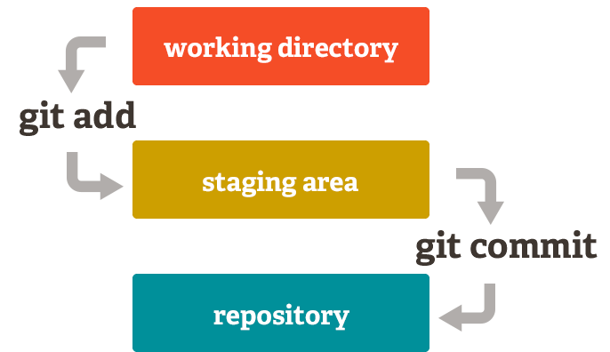

Git log - to track the commits

Git branch --- to chck the branches in repository

Git branch <branch name> -- to create branch

Git checkout <branch name> -- to move to branch

**Merge:**

If you want to merge with master , first move to master branch then

Git merge <branch name which you want to move>

**PUSH to git hub:**

Create account on <https://github.com/>

Click on new repository and give name and create

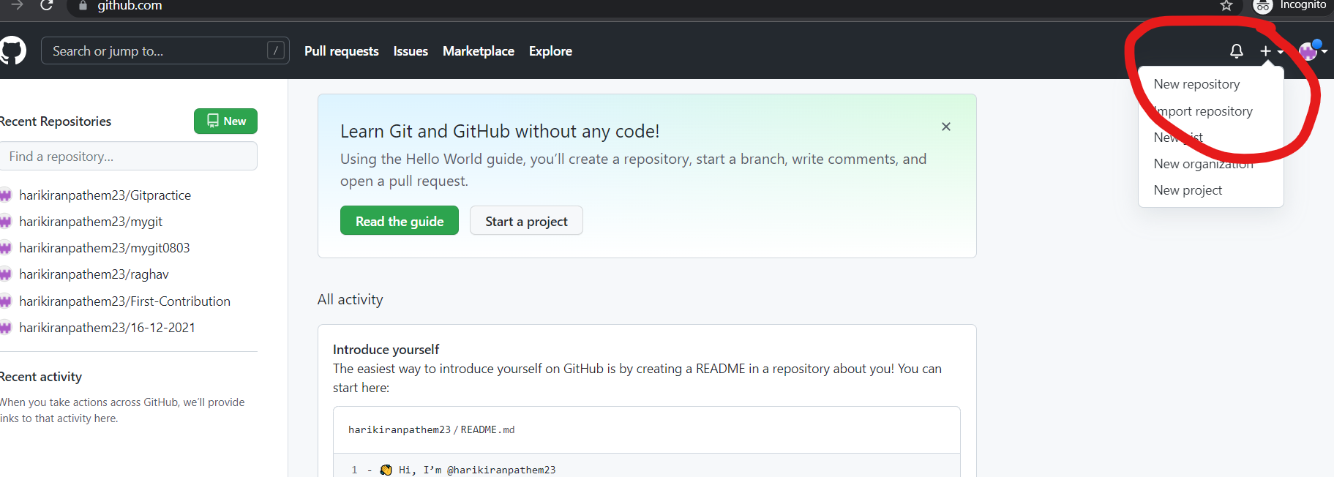

Then follow the 3 commands as shown below

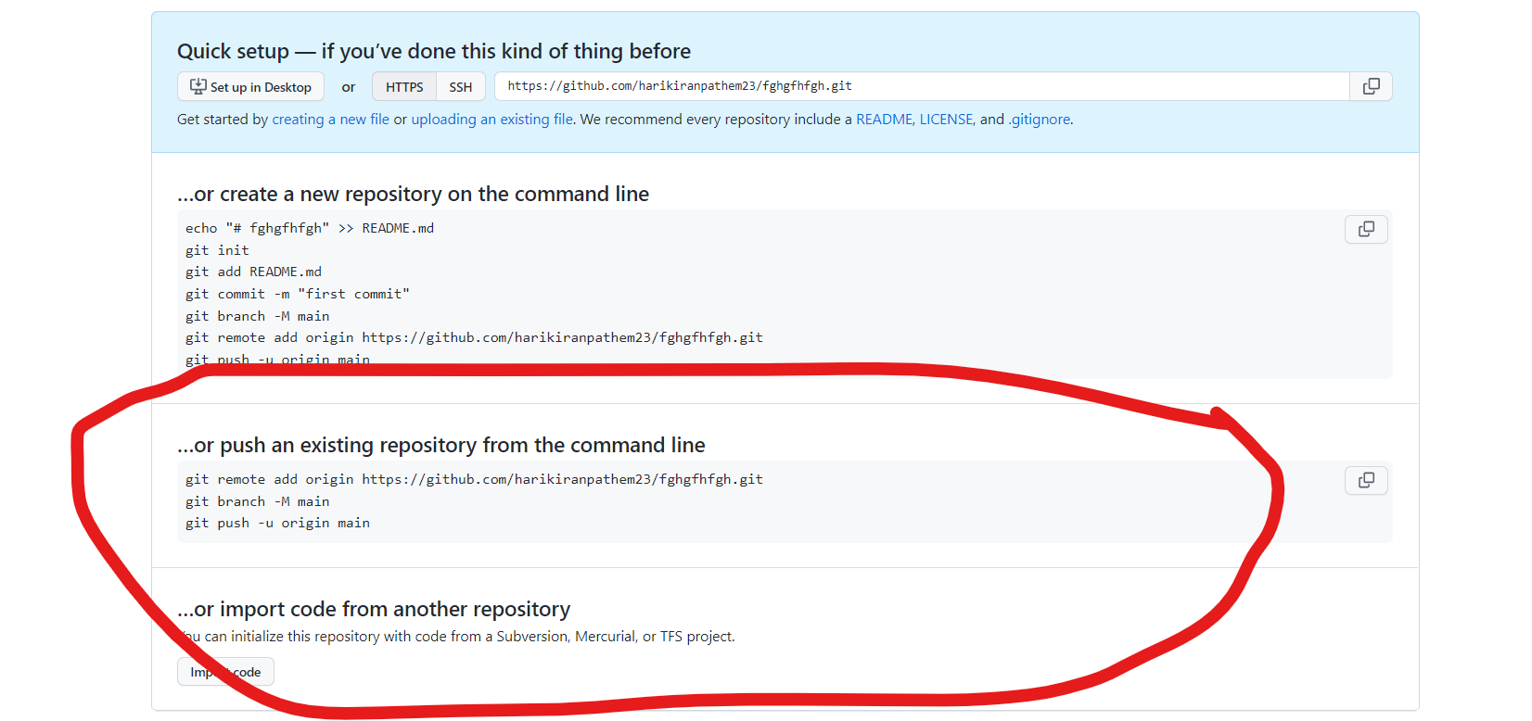

Git remote add origin <url>

Git branch –M master

Git push –u origin master --- if you want to move master

**Git clone**

Open a repository which you want to move to your local

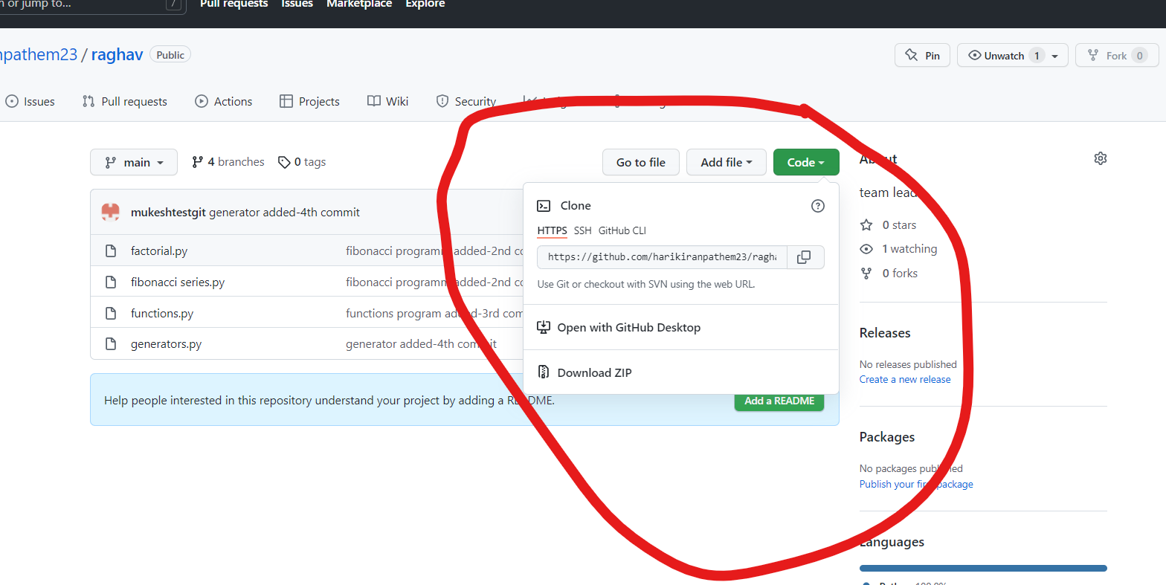

you can use this url:

https://github.com/harikiranpathem23/First-Contribution.git

and use this command to clone to local repository

git clone <url>